Give the site an Icon “CT” standing for “Cool Tech”.

* Use the colours **Cool Tech Orange #EE6C4D** and **Cool Tech Blue #118AB2**

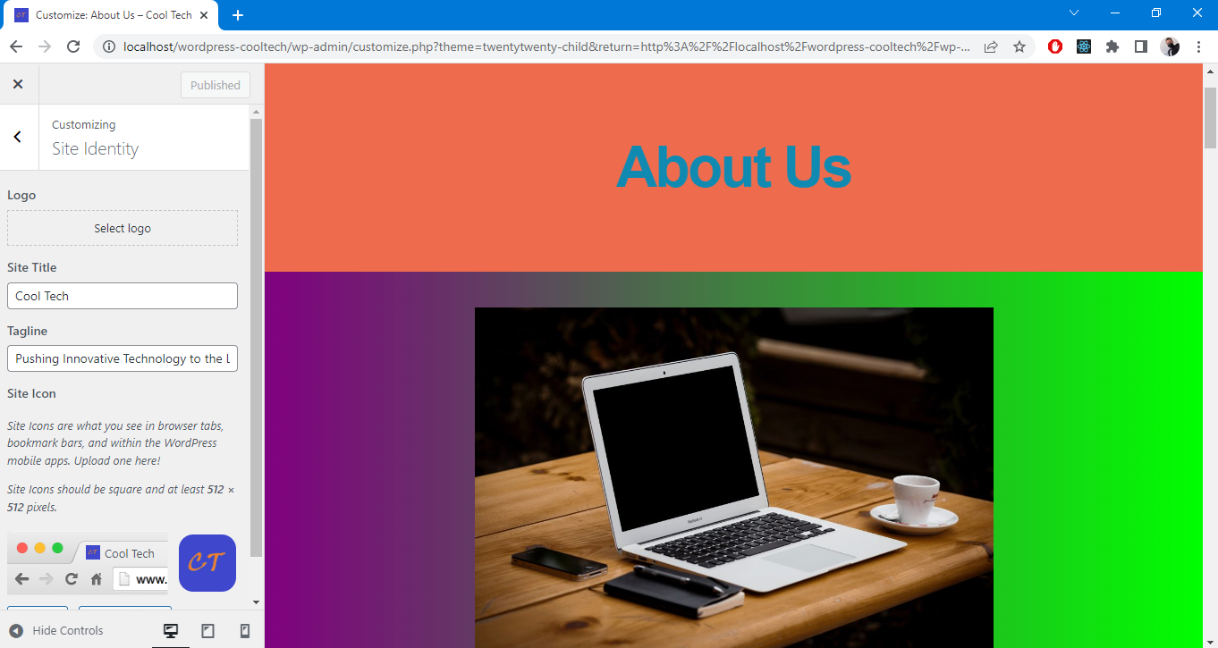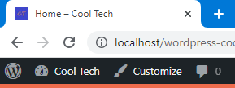

Background Colour: **Cool Tech Orange #EE6C4D**

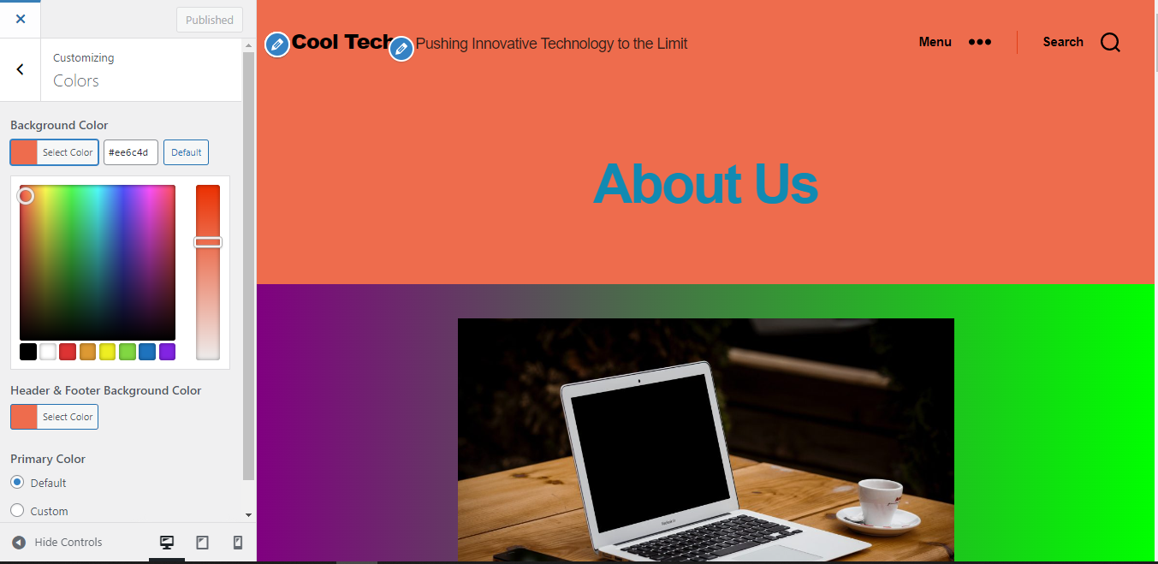

Overlay Background Colour: **Cool Tech Orange #EE6C4D**

Overlay Text Colour: **Cool Tech Blue #118AB2**

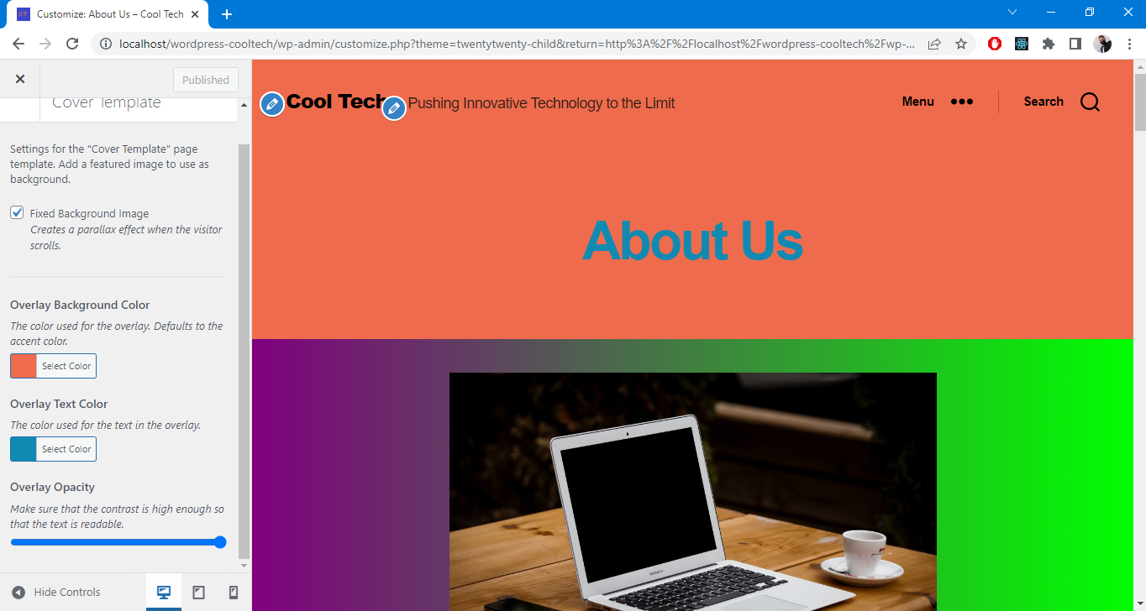

**Child Theme is created**

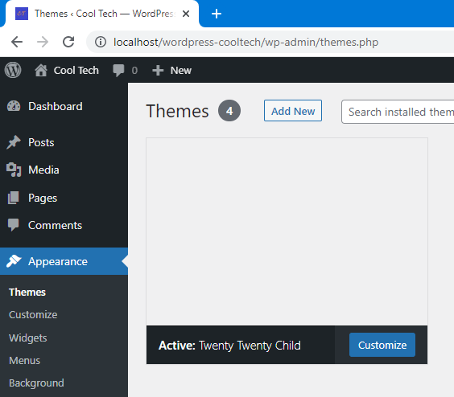

Based on the Colour Wheel:

* **Cool Tech Blue #118AB2** and **Cool Tech Orange #EE6C4D** are opposite colours.
* **Purple** and **Lime** are in the other 2 opposite segments.

Thus used **purple** and **Lime** to make the body stand out.

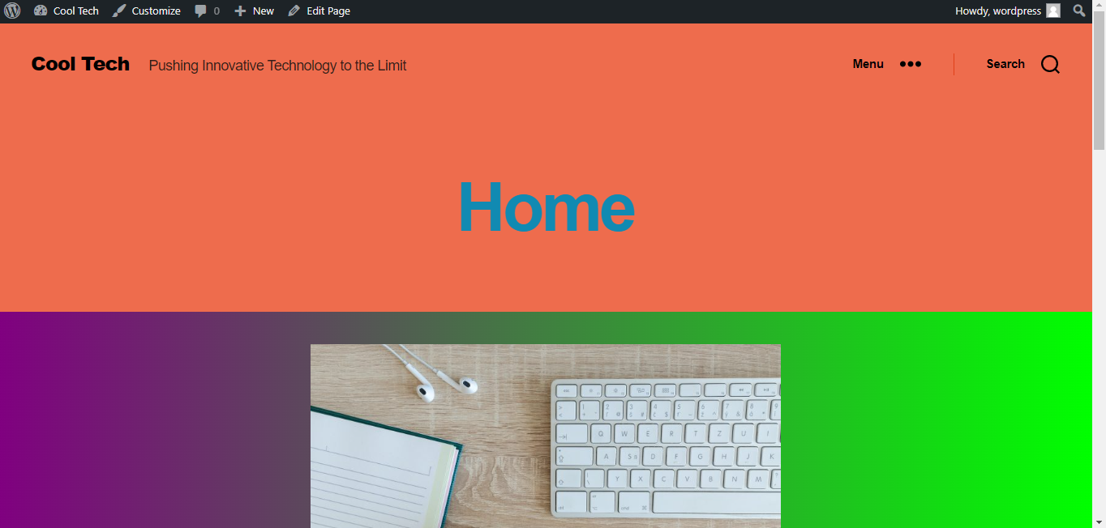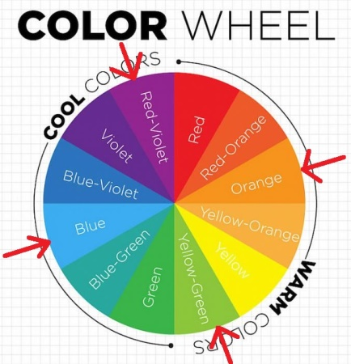

**Post with the required styling in action:**

* Zoom is set to 50% of google chrome to display more content

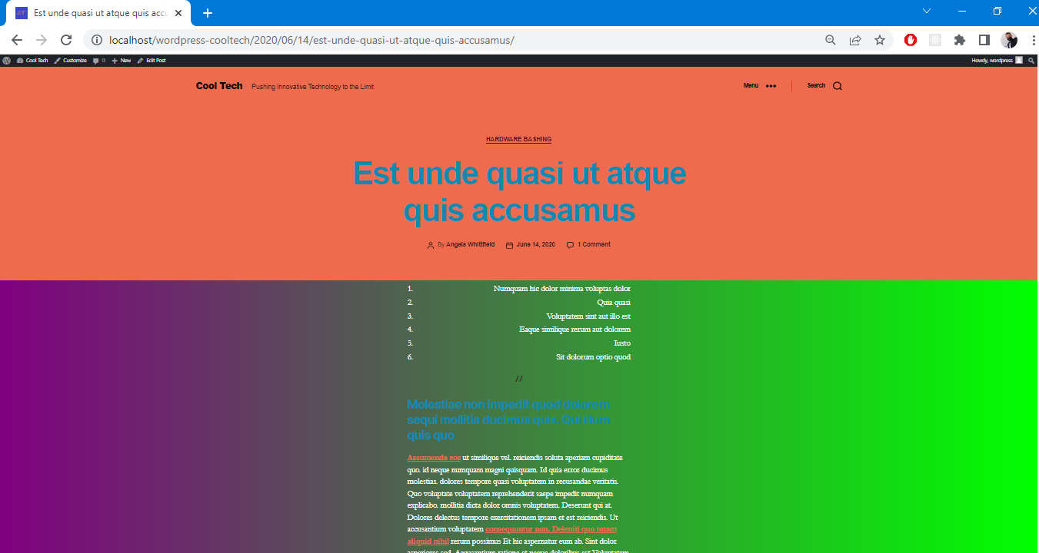

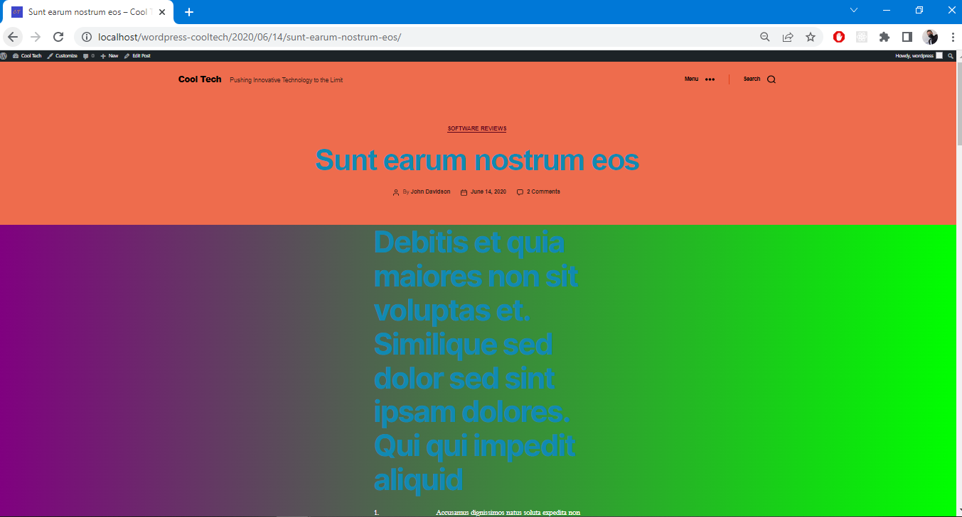

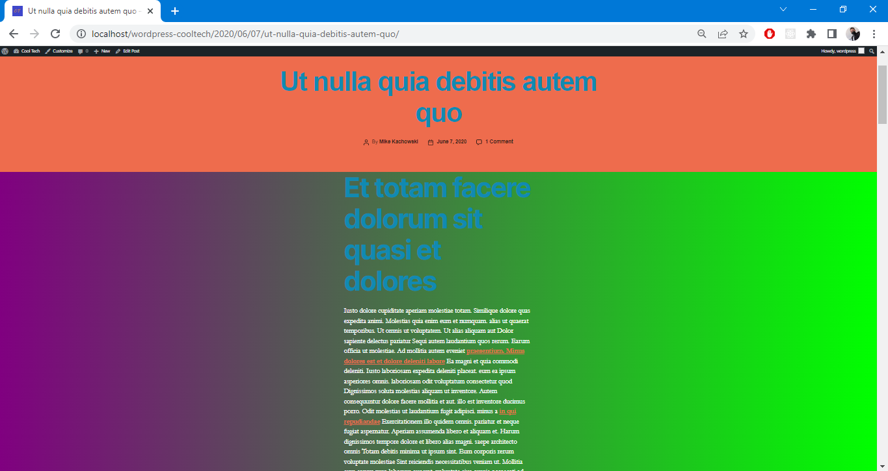

**Pictures added from Lorem:**

